**CSCI585 HW4 Report**

**NAME: Hao Wu**

**USCID:1699530173**

**EMAIL:hwu638@usc.edu**

**Part 1: Google BigQuery**

Query 1**: select name, count from babynames.names_2014**

**where gender = 'M' and name like '_a%' order by coun**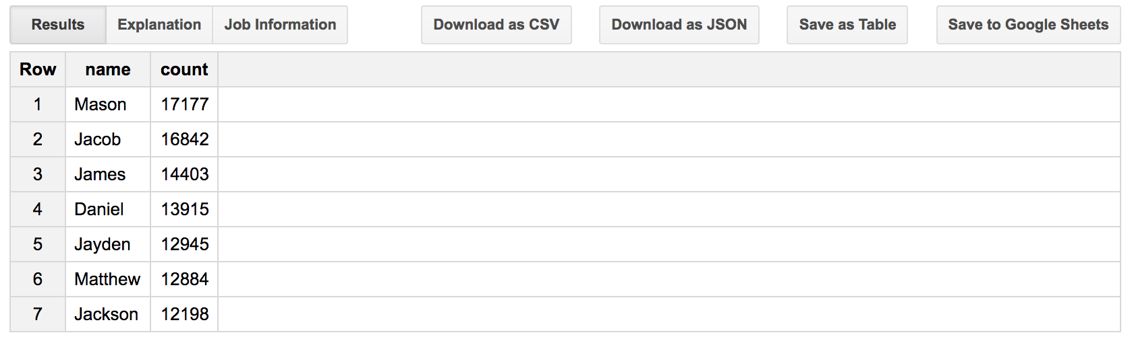

Query 2**:**

**select sum(count) as total_number from babynames.names_2014**

**where name like 'Hao%'**

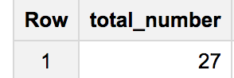

**Part 2: DataLab and Notebooks**

Query in the 2nd cell**:**

**%%bq query**

**SELECT wday**

**FROM `publicdata.samples.natality` where year = 1992 and month = 8 and day = 4**

Query in the 3rd cell:

**%%bq query --name year_count**

**SELECT CAST(source_year AS string) AS year, COUNT(source_year) as year_number**

**FROM `publicdata.samples.natality` where year <> 1992 and month = 8 and day = 4**

**GROUP BY source_year**

**ORDER BY source_year**

**%chart pie --data year_count --fields year,year_number**

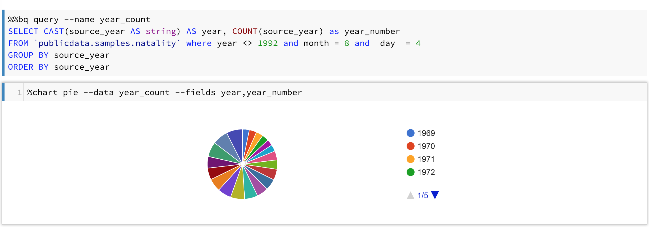

**Part 3: Big Public Data, Visualization and Interpretation**

**Query for this Question:**

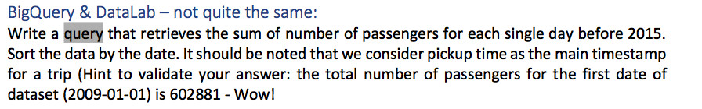

%%bq query --name passenger_count_by_date

#standardSQL

SELECT date_time as day,passenger_count as number

FROM

(SELECT

DATE(pickup_datetime) as date_time

,

SUM(Passenger_count) as passenger_count

FROM

`bigquery-public-data.new_york.tlc_yellow_trips_2010`

GROUP BY

date_time

UNION ALL

SELECT

DATE(pickup_datetime) as date_time

,

SUM(Passenger_count) as passenger_count

FROM

`bigquery-public-data.new_york.tlc_yellow_trips_2009`

GROUP BY

date_time

UNION ALL

SELECT

DATE(pickup_datetime) as date_time

,

SUM(Passenger_count) as passenger_count

FROM

`bigquery-public-data.new_york.tlc_yellow_trips_2011`

GROUP BY

date_time

UNION ALL

SELECT

DATE(pickup_datetime) as date_time

,

SUM(Passenger_count) as passenger_count

FROM

`bigquery-public-data.new_york.tlc_yellow_trips_2012`

GROUP BY

date_time

UNION ALL

SELECT

DATE(pickup_datetime) as date_time

,

SUM(Passenger_count) as Passenger_count

FROM

`bigquery-public-data.new_york.tlc_yellow_trips_2013`

GROUP BY

date_time

UNION ALL

SELECT

DATE(pickup_datetime) as date_time

,

SUM(Passenger_count) as Passenger_count

FROM

`bigquery-public-data.new_york.tlc_yellow_trips_2014`

GROUP BY

date_time

)

ORDER BY

date_time

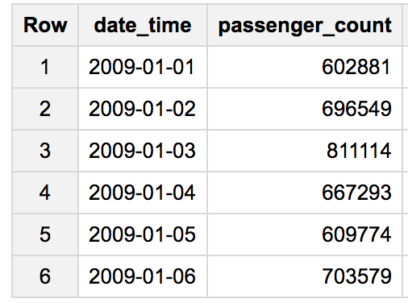

For the question:

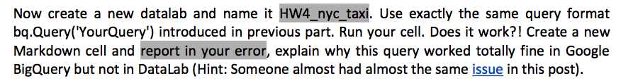

**I didn’t encounter any issues.**

**panda dataframe:**

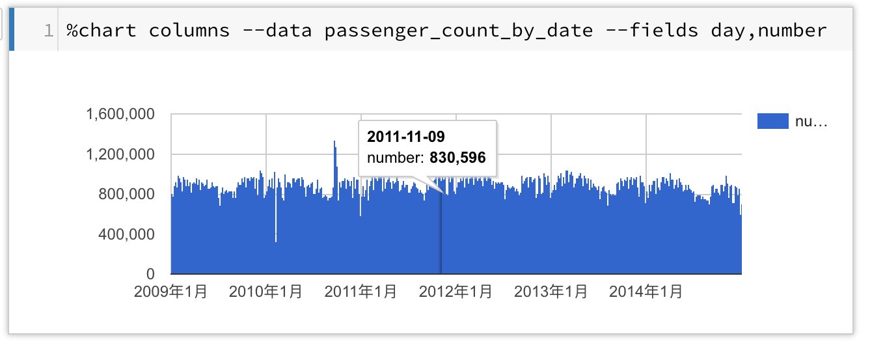

**Visualization:**

**2009**

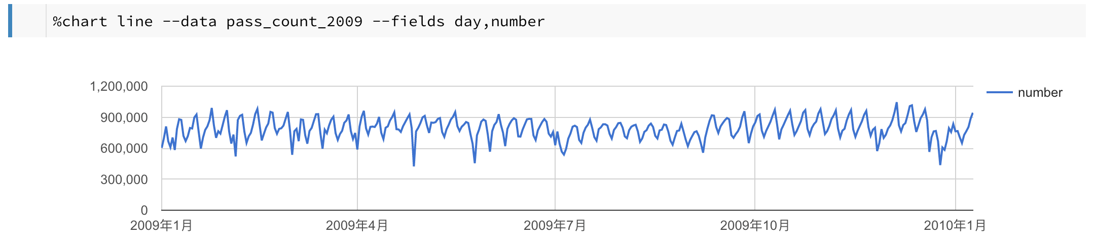

**Query:**

%%bq query --name pass_count_2009

#standardSQL

select DATE as day ,total_passenger as number From(

select DATE(pickup_datetime) as DATE, sum(passenger_count) as total_passenger

from `bigquery-public-data.new_york.tlc_yellow_trips_2009`

Group by

DATE

UNION ALL

select DATE(pickup_datetime) as DATE, sum(passenger_count) as total_passenger

from `bigquery-public-data.new_york.tlc_yellow_trips_2010`

where DATE(pickup_datetime) < '2010-1-10'

Group by

DATE)

Order by

Date

%chart line --data pass_count_2009 --fields day,number

**2010**

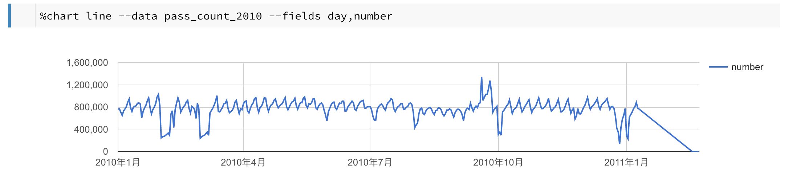

**Query:**

%%bq query --name pass_count_2010

#standardSQL

select DATE as day ,total_passenger as number From(

select DATE(pickup_datetime) as DATE, sum(passenger_count) as total_passenger

from `bigquery-public-data.new_york.tlc_yellow_trips_2010`

Group by

DATE

UNION ALL

select DATE(pickup_datetime) as DATE, sum(passenger_count) as total_passenger

from `bigquery-public-data.new_york.tlc_yellow_trips_2011`

where DATE(pickup_datetime) < '2011-1-10'

Group by

DATE)

Order by

Date

%chart line --data pass_count_2010 --fields day,number

**2014**

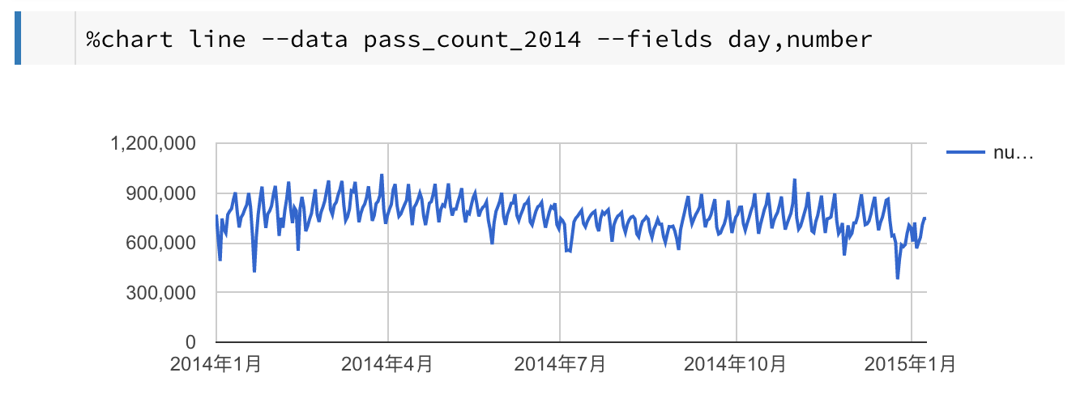

**Query:**

%%bq query --name pass_count_2014

#standardSQL

select DATE as day ,total_passenger as number

from

(

select DATE(pickup_datetime) as DATE, sum(passenger_count) as total_passenger

from `bigquery-public-data.new_york.tlc_yellow_trips_2014`

Group by

DATE

UNION ALL

select DATE(pickup_datetime) as DATE,sum( passenger_count) as total_passenger

from `bigquery-public-data.new_york.tlc_yellow_trips_2015`

where DATE(pickup_datetime) < '2015-1-10'

Group by

DATE

)

Order by

DATE

%chart line --data pass_count_2014 --fields day,number

**For question:**

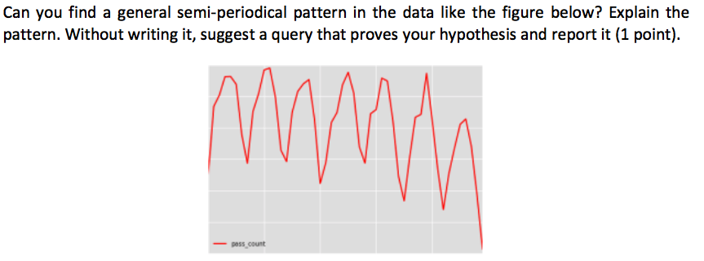

Explanation: The data has fluctuated widely by some reasons (like holiday, ceremony).

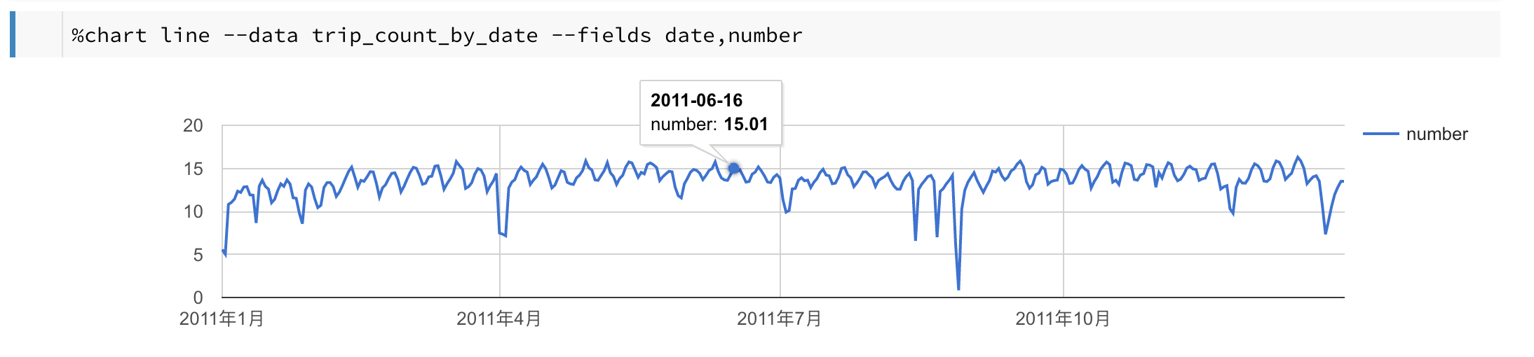

**Query**:

%%bq query --name trip_count_by_date

#standardSQL

SELECT

DATE(pickup_datetime) as date

,

SUM(Trip_distance)/100000 as number

FROM

`bigquery-public-data.new_york.tlc_yellow_trips_2011`

GROUP BY

date

ORDER BY

Date

%chart line --data trip_count_by_date --fields date,number

For question:

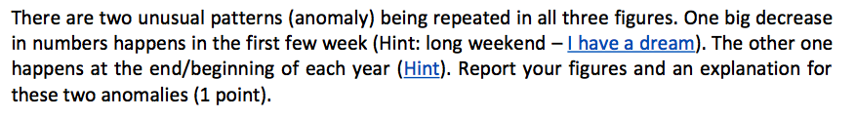

The big decrease is happened at Martin Luther King Day. In that day, most people have spare time to go out. So, there should be a lot of people using taxi.

The other one is happened during Christmas Day. Same reason for it, people will take taxi more often than usual on holiday. Another reason is may that lots of people go to New York for travel.

For question:

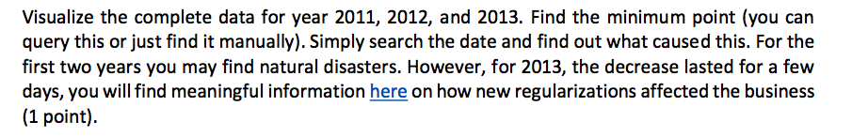

For 2011, the minimum point is at the day August 28. This is caused by hurricane Irene.

For 2012, the minimum point is at the day Nov. 29. This is caused by hurricane sandy.

For 2013, the minimum point is at the day August 04. The reason for this is because **“New York City licensed a new type of taxi in Aug. 2013: “boro” taxis are restricted from picking up passengers in Manhattan south of a boundary along East 96th Street and West 110th Street.”**

Bonus Part:

#standardSQL

SELECT

pickup_datetime as date_time,

Total_amount as amount,

Pickup_longitude as p_lo,

Pickup_latitude as p_la,

Dropoff_longitude as d_lo,

Dropoff_latitude as d_la

FROM

`bigquery-public-data.new_york.tlc_yellow_trips_2013`

where Total_amount between 300 and 400 and extract(hour from pickup_datetime) > 18

I use the above query to get the pickup longitude(p_lo), pickup latitude(p_la), dropoff_longitude(d_lo) and dropoff_latitude(d_la). Then I save the result as csv format and import the csv file into google map. The snapshot is in the below.

